**Administrative**

**Today’s session**

Unified modeling language (UML)

BigInteger

Assertions

Object serialization

Homework 6

**Session Topics**

**Unified modeling language (UML)**

● UML is used to model a software system.

● A UML diagram has two main parts:

✓ The **structure** of the system, its objects, attributes, operations and relationships.

✓ The **behavior** of the system, its interaction among objects and changes to the internal states of objects.

● Here is the hierarchy of UML diagram types that may be used to model a software system:

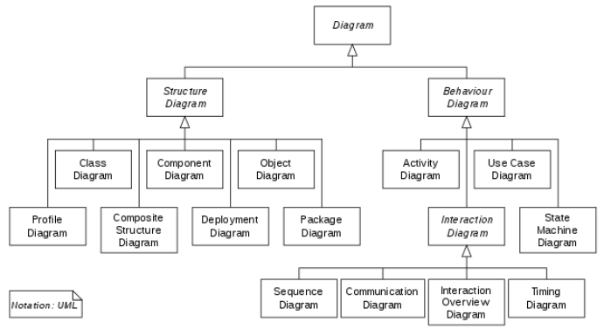

● The **class diagram** is one of the key diagrams since it summarizes:

✓ The content of a class including its name, fields, and methods.

✓ The relationships among classes including association and cardinality.

● Here is a sample class diagram:

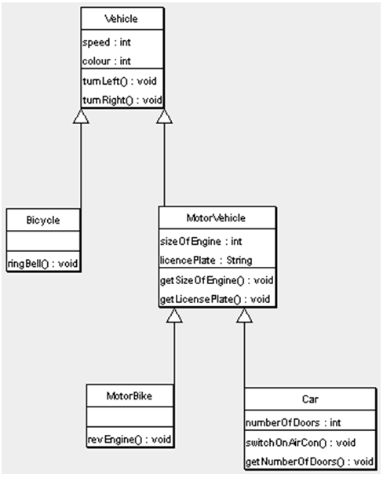

● The Eclipse Marketplace offers several add-ins including some that support UML diagramming.

● To access the Eclipse Marketplace, select **Help / Eclipse Marketplace …**

**BigInteger**

● Data type **int** stores whole numbers in four bytes while data type **long** stores whole numbers in eight bytes.

● Data type **BigInteger** represents whole numbers as a sequence of digits.

● The maximum number of digits is HUGE: if a BigInteger object is created from a string, up to Integer.MAX_VALUE digits (2,147,483,647 characters) may be specified.

● See **BigInteger data type** sample application on Blackboard.

**Assertions**

● The **assert statement** may be used to debug an application.

● The assert statement may be placed anywhere in a program.

● The assert statement has syntax:

assert <boolean-expression>;

✓ If the <boolean-expression> is false, an AssertionError exception is triggered and the program ends.

OR

assert <boolean-expression> : <string-expression>;

✓ If the <boolean-expression> is false, an AssertionError exception is triggered with <string-expression> as the message.

● Assertion handling must be enabled with command-line argument **enable-assertions (ea)**.

● In Eclipse, command-line argument -ea is specified as a VM argument:

1) From the Eclipse main screen, select **Run / Run Configurations …**

2) From the Run Configurations screen, select a Java application, tab Arguments, and pane VM arguments.

3) From the Run Configurations screen, enter VM argument **-ea**, and click **Close**.

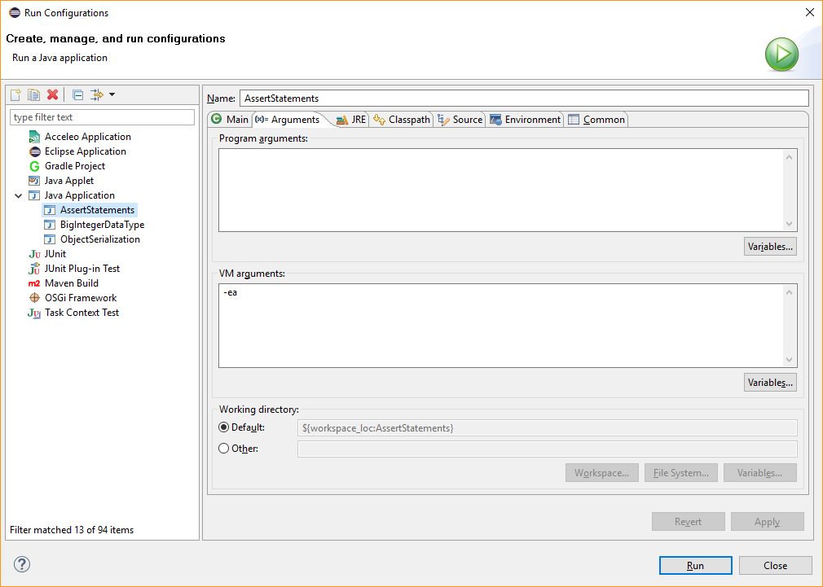

● See **Assert statements** sample application on Blackboard.

**Object serialization**

● Just as text data may be read and written, so can object data be read and written.

● When text data is written, only the data is written and not information about the data.

● When object data is written, both the data and information about the data is written. This is so that objects may be read and reconstructed.

● To enable object serialization:

✓ In the object’s class, implement the **Serializable** interface.

✓ In the main class, to write the objects:

→ Create an **ObjectOutputStream** object.

→ Write objects to the ObjectOutputStream object.

→ Close the ObjectOutputStream object.

✓ In the main class, to read the objects:

→ Create an **ObjectInputStream** object.

→ Read objects from the ObjectInputStream object.

→ Close the ObjectInputStream object.

● See **Object serialization** sample application on Blackboard.

**Homework 6**

● Assigned today.

● Available on Blackboard.

● Due in one week.